

***Corporate Administrator Manual***

Update: June 4, 2018

**Table of Contents**

1. Overview 5

1-1. System Requirements 5

1-2. User Types and Their Definitions 5

2. Login 7

2-1. Setting the Initial Password 7

2-2. Log In 7

2-3. Log in Using the PKI Client Certificate 8

2-4. Resetting the Password 9

2-5. Changing the Password 9

3. User Management 10

3-1. Registering a New User 10

3-2. Searching Users 14

3-3. Changing Administrator or User Information 15

3-4. Editing Information for Multiple Users 16

3-5. Deleting Users 19

3-6. Importing Users 20

3-7. Importing Users Share setting 24

3-8. Exporting User List, Current Data Usage / Most Recent Sign-in Date, Share Setting List 28

3-9. Locking User Accounts 30

3-10. Emergency locking User Accounts 31

3-11. File View / Owner Change 32

3-11-1. View files/folder 32

3-11-2. Owner Change 33

3-11-3. Empty trash 46

4. Corporate Administration 47

4-1. Editing Corporate Policies 47

4-1-1. Home time limit setting 55

4-1-2. PrimeDrive for Office Online 58

4-2. Viewing Subscription Information 60

5. Group Management 61

5-1. Registering a New Group 61

5-2. Editing a Group 62

5-3. Deleting Groups 64

5-4. Browse the group members. 64

5-5. Group Import 64

5-6. Group Export 66

6. IP Address Connection Limit 68

6-1. How to Register IP Addresses 68

6-2. Applying or Releasing IP Address Connection Limits for the Whole Corporate Account 68

6-3. Applying or Releasing IP Address Connection Limits for Individual Users 69

7. PKI Client Authentication Function 71

7-1. Setting Preparation In Advance 71

7-2. Restrictions 71

8. Log Management 73

8-1. Searching Logs 73

8-2. Detail Logs 73

8-3. Exporting Logs 74

8-4. Acquiring past logs 75

9. Service usage 77

9-1. Checking Service usage 77

10. Registration Information 78

10-1. Registering Notice Information 78

10-2. Changing or Deleting Notice Information 78

11. Notification Email Template Registration 79

11-1. Notification Email Template Registration 79

# Overview

## System Requirements

PrimeDrive is required to operate in the following client environment.

System Requirements

|  |  |
| --- | --- |
| Hardware | Operating System / Browser |
| CPU: Pentium4 2GHz or faster  Free Memory: 512MB or above  Free storage space: 500MB or above | Windows 7(32 / 64bit) / 8(32/64bit) / 10(32 / 64bit)  Internet Explorer 11 / Chrome / Firefox |
| Mac OS X  Safari5 or above |

* Recommended Browser: Internet Explorer11.0, Chrome (latest edition), Firefox (latest edition), Safari (latest edition)
* IME does not work properly in Chrome.
* For Internet Explorer 10.0, Click on Compatibility View to uncheck it.
* Windows8.0 users need to upgrade to Windows8.1.

## User Types and Their Definitions

The user types offered in PrimeDrive are shown in the following table:

User Types and Their Definitions

|  |  |
| --- | --- |
| User Type | Definition |
| Corporate  Administrator | Can register, edit, and delete sub-administrator, standard user, and contractor accounts.  Cannot delete corporate administrator accounts.  (Can edit corporate administrator accounts) |
| Sub-administrator | Can perform the same operations as the corporate administrator. Except Office Online setting. |
| Standard User | Can use functions within the user policy setting range after being registered by the corporate administrator or the sub-administrator. |
| Contractor | Can use functions within the user policy setting range after being registered by the corporate administrator or the sub-administrator.  The contractor can refer to member information only if group member information, including his or her own, is published to contractors. |

# Login

## Setting the Initial Password

After the administrator registers a user, a user registration completion notification email containing the login information will be sent to the registered email address.

1. Click the URL for password setting contained in the user registration completion notification email.
2. Register optional password information according to the Password Policy.

## Log In

(Login URL)

https://primedrive.jp/admin/Corporate ID

* The last portion of the login URL is the corporate ID

(DR site login URL)

https://s.primedrive.jp/admin/corporate ID

* By changing access point of DR site (above URL) when a disaster strikes, users can use PrimeDrive service continuously.

Enter your corporate ID, user ID, and password in the information input fields on the login screen and click the "Login" button.

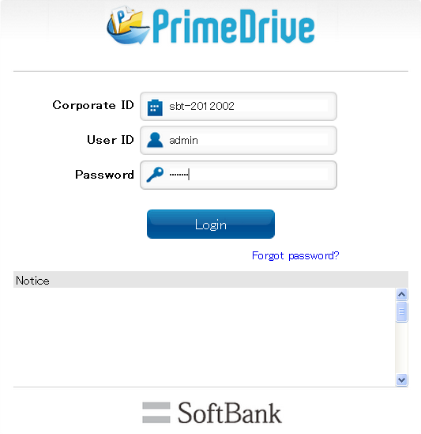

## Log in Using the PKI Client Certificate

When you log in to your account using the PKI client certificate, you must login from the login URL for PKI authentication.

(PKI authentication login URL)

https://secure.primedrive.jp/admin/Corporate ID

* The last portion of the login URL is the corporate ID

(DR site login URL)

https:// secure.s.primedrive.jp/admin/corporate ID

* By changing access point of DR site (above URL) when a disaster strikes, users can use PrimeDrive service continuously.
* PKI certificates, which are invalid due to the expiration date being passed, are valid in DR site.

1. Click the login URL for PKI authentication.
2. Select the certificate you will use from the certificate selection screen.
3. Since the login screen with a fixed corporate ID and user ID will be displayed, enter the password in the password input field and click the "Login" button.

* When the account is set not to use password authentication through the user policy settings, the login screen display will be omitted after you click the login URL and the screen right after login completion will be displayed.

## Resetting the Password

1. Click "Forgot password?" on the Login screen.
2. Enter your Corporate ID and User ID in the Reset Password screen, and click "Send".
3. Click the URL on the password reset notification email.
4. Register a new password in the Reset Password screen and click the "OK" button.

## Changing the Password

1. Select “User Search” from the left menu on the Main screen and search for the target user.
2. Select the target user from the User Information screen and click the "Edit" button.
3. Enter new information in the password input field and click the "Register" button.
4. Click "Confirm" on the next screen.

* The corporate/sub-administrator can also change password information from his/her own user account. Refer to the user manual on how to operate.

# User Management

## Registering a New User

1. Select "New User" from the left menu of the Main screen.
2. Register user information and click the "Register" button.
3. On the confirmation screen, click the "Confirm" button or the " Confirm (Add another)" button.

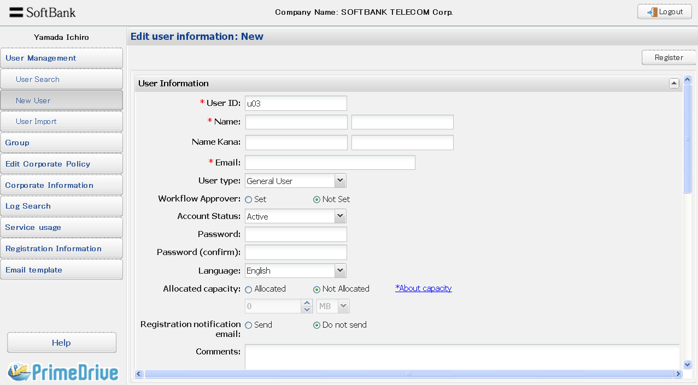

Basic User Information

|  |  |  |
| --- | --- | --- |
| Item Name | Description | Input |
| User ID | Up to 128 half-width alphanumeric characters. It will not be possible to change the User ID later.  (Other conditions)  · In the same corporate, the same user ID cannot be registered.  · case-sensitive  · Only the following special characters are allowed: “-“  hyphen, “_” underscore, “.” period, and “@” at mark.  · User IDs with only “.” or “..” are not allowed.  <Note>  When using a PKI certificate, the PrimeDrive user ID and the CN of the certificate must match. Since the CN does not allow the “@” character, please use characters other than the “@” character in the PrimeDrive user ID. | Required |
| Last Name | Text format up to 64 | Required |
| First Name | Text format up to 64 | Required |
| Last Name  (Kana) | Text format up to 64 | - |
| First Name  (Kana) | Text format up to 64 | - |
| Email | Half-width up to 128 alphanumeric characters. It is possible to register multiple email addresses. | Required |
| User Type | Select from Sub-administrator/Standard User  (initial value)/Contractor. | Required |
| Workflow  Approver | Specifies the workflow approver.  A contractor cannot specify an approver. | - |
| Account Status | If the number of failed attempts during login authentication exceeds the specified value, the account will automatically be changed to a locked status. "*Exceeded the authentication error limit" will be displayed on the right side. | - |
| Password | The input must follow the specified conditions of the corporate policy settings.  (Other conditions)  ・Up to 32 half-width alphanumeric characters.  ・case-sensitive  ・There is not the prohibition letter.  ・But a control letter and the space such as TAB or the  newline code are unusable  ・You cannot use an your e-mail address and user ID.  ・There is not the limitation of the top letter.( the top of the  password can appoint a number and a sign) | - |
| Password  (confirm) | Re-enter password for confirmation. | - |
| Language | Sets the screen language. This does not apply to stored  file/folder names. | - |
| Allocated  capacity | If you select "Specify", you can specify the capacity.  If you select "Not specified", your subscribed capacity will be the maximum.  Enter capacity number in range of 0 to 999.  When the capacity is set to 0, uploading on Home is not available. (It is possible to upload on folder shared by other users.) | - |
| Unit | You can select MB/GB/TB. | - |
| Registration  notification email | After completing user registration, a notification email will be sent automatically. | - |
| comment | You can input to 2,000 characters | - |

User Policy

|  |  |
| --- | --- |
| Item Name | Description |
| IP address  connection  restriction | Sets the usage validity of the IP address restriction function. If you select "Apply corporate policy", the account will follow the corporate policy setting. |
| Apply corporate policy/ Apply a user policy/ No restriction |
| List of connection  allowed IP  addresses | Sets the global IP address or range with permitted access. |
| PKI authentication | If you select "Available", a PKI client certificate will be required during login authentication. |
| Available/Not available |
| PKI authentication /  Password  authentication | A password will be required during login authentication. |
| Available/Not available |
| Issue send key | If you select "Do not allow", the user will not be able to use the send function. |
| Allow/Do not allow |
| Issue send key /  Password | If you select "required", setting a password for the send key will be required. |
| required /Do not required |
| Issue send key /  Input name | If you select "required", entering a name for the send key will be required. Name entering is a function that makes the performer of the action enter a name and a company name during download. |
| required /Do not required |
| Use "Send as  email attachments"  (iPad/iPhone) | If you select "Do not allow", the user will not be able to use  "Send as email attachments" in iPad/iPhone. |
| Allow/Do not allow |
| Use "Open In"  (iPad/iPhone) | If you select "Do not allow", the user will not be able to use  "Open In” in iPad/iPhone.  The user will not be able to use PrimeDrive for Office Online in iPad/iPhone. |
| Allow/Do not allow |
| Issue collect key | If you select "Do not allow", the user will not be able to use the collect function. |
| Allow/Do not allow |
| Workflow use | If you select "required", approval from the approver will be necessary for the issuance of send keys for all files or folders inside the account. |
| Available/Not available/required |
| Available Devices  /web Browser | If you select "Not available", usage from a Web browser will be restricted. |
| Available/Not available |
| Available Devices  /DTA | If you select "Not available", usage from a DTA will be restricted. |
| Available/Not available |
| Available Devices  /iPhone App | If you select "Not available", usage from an iPhone app will be restricted. |
| Available/Not available |
| Available Devices  /iPad App | If you select "Not available", usage from an iPad app will be restricted. |
| Available/Not available |
| Available Devices  /Android App | If you select "Not available", usage from an Android app will be restricted. |
| Available/Not available |
| Local Mail Settings | Sets the type of mailer that you will use to prevent the email body from being garbled during notification sending from the local mailer. |
| ・Before OutlookExpress6 or Outlook2003  ・Windows Mail  ・Outlook2007/2010/2013/2016  ・Mac OS Mail  ・Thunderbird |

## Searching Users

* + - * 1. Easy Search

1. Select "User Search" from the left menu of the Main screen. Input the user ID and click the “Search” button.

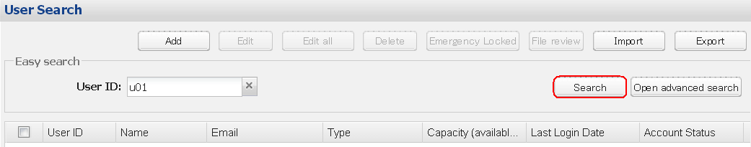

* Clicking the X icon beside “User ID” box will clear the inputted user ID, displaying all users.
  + - * 1. Advanced Search

Select "User Search" from the left menu of the Main screen. Click the “Open advanced search” button.

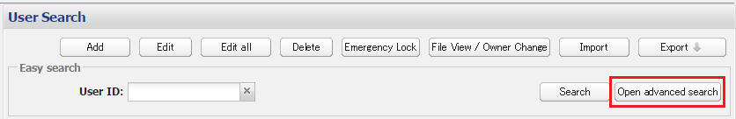

* Input the search parameters and click the “Search” button.

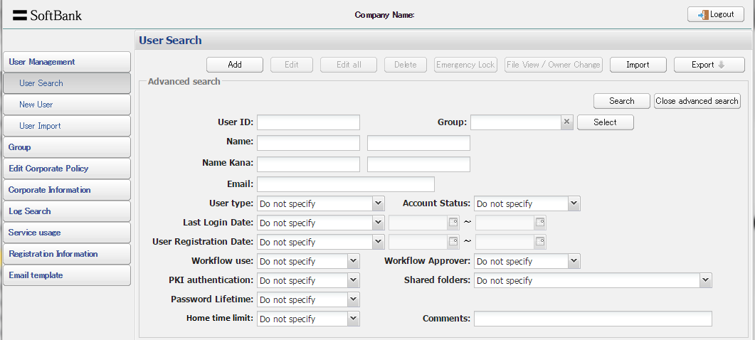

* Clicking the X icon beside the “Group” box will clear the selected group.

## Changing Administrator or User Information

1. Select “User Search” from the left menu on the Main screen and search for the target user.
2. Select the target user from the User Information screen and click the "Edit" button.
3. Edit the registered information and click the "Register" button.
4. Click "Confirm" on the next screen.

## Editing Information for Multiple Users

1. Select “User Search” from the left menu on the Main screen and search for the target users.
2. Select the target users from the User Information screen and click the "Edit all" button.
3. Edit the registered information and click the "Register" button.
4. Click "Confirm" on the next screen.

Basic User Information (Edit all)

|  |  |
| --- | --- |
| Item Name | Description |
| User Type | Select from Sub-administrator/Standard User  (initial value)/Contractor. |
| Workflow  Approver | Specifies the workflow approver.  A contractor cannot specify an approver. |
| User Usage  Condition | If the number of failed attempts during login authentication exceeds the specified value, the account will automatically be changed to a locked status. |
| Language | Sets the screen language. This does not apply to stored  file/folder names. |

User Policy (Edit all)

|  |  |
| --- | --- |
| Item Name | Description |
| IP address  connection  restriction | Sets the usage validity of the IP address restriction function.  If you select "Apply corporate policy", the account will follow the corporate policy setting. |
| Apply corporate policy/ Apply a user policy/ No restriction |
| List of connection  allowed IP  addresses | Sets the global IP address or range with permitted access. |
| PKI  authentication | If you select "Available", a PKI client certificate will be required during login authentication. |
| Available/Not available |
| PKI authentication /  Password  authentication | A password will be required during login authentication. |
| Available/Not available |
| Issue send key | If you select "Do not allow", the user will not be able to use the send function. |
| Allow/Do not allow |
| Issue send key /  Password | If you select "required", setting a password for the send key will be required. |
| required /Do not required |
| Issue send key /  Input name | If you select "required", entering a name for the send key will be required. Name entering is a function that makes the performer of the action enter a name and a company name during download. |
| required /Do not required |
| Use "Send as  email  attachments"  (iPad/iPhone) | If you select "Do not allow", the user will not be able to use  "Send as email attachments" in iPad/iPhone. |
| Allow/Do not allow |
| Use "Open In"  (iPad/iPhone) | If you select "Do not allow", the user will not be able to use  "Open In” in iPad/iPhone.  The user will not be able to use PrimeDrive for Office Online in iPad/iPhone. |
| Allow/Do not allow |
| Issue collect key | If you select "Do not allow", the user will not be able to use the collect function. |
| Allow/Do not allow |
| Workflow use | If you select "required", approval from the approver will be necessary for the issuance of send keys for all files or folders inside the account. |
| Available/Not available/required |
| Available Devices  /web Browser | If you select "Not available", usage from a Web browser will be restricted. |
| Available/Not available |
| Available Devices  /DTA | If you select "Not available", usage from a DTA will be restricted. |
| Available/Not available |
| Available Devices  /iPhone App | If you select "Not available", usage from an iPhone app will be restricted. |
| Available/Not available |
| Available Devices  /iPad App | If you select "Not available", usage from an iPad app will be restricted. |
| Available/Not available |
| Available Devices  /Android App | If you select "Not available", usage from an Android app will be restricted. |
| Available/Not available |
| Local Mail Settings | Sets the type of mailer that you will use to prevent the email body　from being garbled during notification sending from the local mailer. |
| ・Before OutlookExpress6 or Outlook2003  ・Windows Mail  ・Outlook2007/2010/2013/2016  ・Mac OS Mail  ・Thunderbird |

## Deleting Users

1. Select User Search from the left menu on the Main screen and search for the target user.
2. Select the target user from the User Information screen and click the "Delete" button.
3. If the target user want to keep files owned by him, uncheck the checkbox "Delete user's files" in the confirm dialog, then click the "OK" button. Files owned by the user will be moved to the home folder of the corporate administrator.

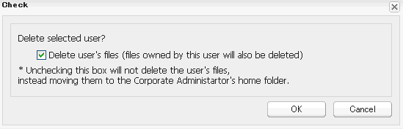

* Sharing setting, expiration date, send key, collect key of the original files/folders will be released (however, lock, version and capacity setting are maintained)
* Files in Trash are not moved.
* If amount of free space of corporate administrator is insufficient, it is not able to delete user which keep files.
* The following will be recorded at the content column of the user delete log: "File moved": Keep files, "Empty": No file to keep.
* It is not able to keep files when use user import function to delete user (everything will be deleted)
* You cannot recover the deleted user's files.

## Importing Users

1. Select Import from the left menu of the Main screen.
2. Select "User import" tab on the Main screen.

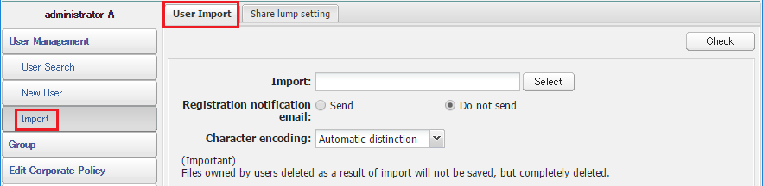

1. Click the "Select" button and select the file to import.

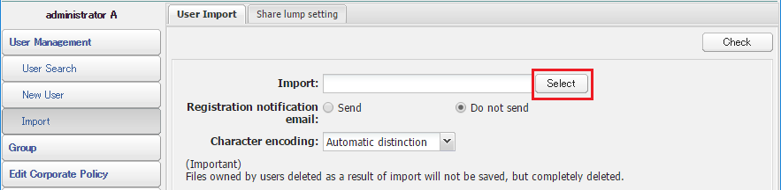

* The CSV file exported by the user can be used as the template of the import file (CSV).
* The max number of import is 3000 at one operation.
* The first line of the import file is handled as a line name.
* Deletion processing of a large number of users belonging to a group may take time.
* It is not able to keep files when use user import function to delete user (everything will be deleted)

Import User file (CSV) format

|  |  |  |  |  |
| --- | --- | --- | --- | --- |
| Item Name | Required | Initial Value | Input  Value | Description |
| Operation | ○ |  | 11 | Add users |
| 12 | Edit user |
| 13 | Delete user |
| 31 | Add IP address |
| 33 | Delete IP address |
| 99 | none |
| User ID | ○ | - | - |  |
| Password | ○ | Automatically  generated | - | Only case of 11 in Operation |
| Last Name | ○ | - | - | case of 11,12 in Operation |
| First Name | ○ | - | - | case of 11,12 in Operation |
| Last Name  (Kana) | - | - | - |  |
| First Name  (Kana) | - | - | - |  |
| Email | ○ | - | - | case of 11,12 in Operation |
| User Type | - | 3 | 2 | Sub-administrator |
| 3 | Standard User |
| 4 | Contractor |
| Workflow  Approver | - | 0 | 1 | Set |
| 0 | Not set |
| Account Status | - | 0 | 1 | Locked |
| 0 | Unlocked |
| Language | - | ja | ja | Japanese |
| en | English |
| Allocated  Capacity  settings | - | 0 | 1 | Allocated |
| 0 | Not Allocated |
| Allocated  Capacity  settings  /Capacity | - | - | - |  |
| Allocated  Capacity  settings /Unit | - | MB | MB |  |
| GB |  |
| TB |  |
| PKI  Authentication | - | 0 | 1 | Available |
| 0 | Not available |
| Password Authentication | - | 0 | 1 | Available |
| 0 | Not available |
| Issue send key | - | 1 | 1 | Allow |
| 0 | Do not allow |
| Password | - | 0 | 1 | Required |
| 0 | Do not require |
| Enter name | - | 0 | 1 | Required |
| 0 | Do not require |
| Use Send as  email  attachments  (iPad/iPhone) | - | 1 | 1 | Allow |
| 0 | Do not allow |
| Use Open In  (iPad/iPhone) | - | 1 | 1 | Allow |
| 0 | Do not allow |
| Issue collect key | - | 1 | 1 | Allow |
| 0 | Do not allow |
| Workflow use | - | 0 | 2 | Required |
| 1 | Available |
| 0 | Not available |
| Available  Devices/web | - | 1 | 1 | Available |
| 0 | Not available |
| Available  Devices/iPhone | - | 1 | 1 | Available |
| 0 | Not available |
| Available  Devices/iPad | - | 1 | 1 | Available |
| 0 | Not available |
| Local Mail  Setting | - | 1 | 1 | Outlook Express and Outlook 2003  below |
| 2 | Windows Mail |
| 3 | Outlook 2007/2010/2013/2016 |
| 4 | MacOS Mail |
| 5 | Thunderbird |
| IP address  connection limit | - | 2 | 0 | No restriction |
| 1 | Apply a user policy |
| 2 | Apply corporate policy |
| IP address /  access scope of  permission | - | - | - | Required only case of 31,33 in  Operation |
| Comments | - | - | - | Up to 2000 characters can be entered |
| Available  Devices / DTA | - | 1 | 1 | Available |
| 0 | Not available |
|  |  |
| Available  Devices / Android | - | 1 | 1 | Available |
| 0 | Not available |
|  |  |
| Upload from other applications to [Shared folders] | - | 0 | 1 | Available |
| 0 | Not available |
|  |  |
| Home time limit setting | - | 0 | 1 | Available |
| 0 | Not available |
|  | *When this item is blank, we import the user by default setting. |

## Importing Users Share setting

1. Select Import from the left menu of the Main screen.
2. Select "Share lump setting" tab on the Main screen.

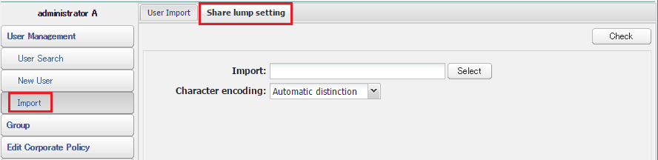

1. Click "Select" button and select the file to import.

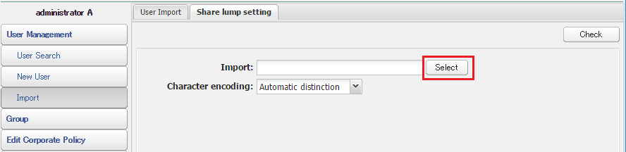

* You can edit CSV file which you exported as a template and import it as well.
* You can add share members. But, those members cannot configure share setting at the same time.
* The maximum number is 3,000 at one time.
* First row of csv file is considered as item name for share setting.

Import share setting file (CSV) format

|  |  |  |  |  |  |  |  |
| --- | --- | --- | --- | --- | --- | --- | --- |
| **Item Name** | **Input**  **Value** | **Description** | **Required** | | | | |
| 11 | 12 | 13 | 23 | 99 |
| Operation | 11 | Add Share Setting/Add Share Member | ○ | － | － | － | － |
| 12 | Edit Share Setting | － | ○ | － | － | － |
| 13 | Release Share Setting | － | － | ○ | － | － |
| 23 | Delete Share Member | － | － | － | ○ | － |
| 99 | None | － | － | － | － | ○ |
| Share Name | - | Share Name | ○ | ○ | ○ | ○ | － |
| Full Path of the share name(Share setter) | - | Folder path for Share setting  ※Specify a path from share setter’s point  ＜Specify format＞  When you share folders below home folder :  /User ID/ folder name  When it is shared below the shared folder :  / share name @( Owner user ID )/ folder name | ○ | ○ | ○ | ○ | － |
| Share Setter (ID) | - | A user (user id) who shares folders | ○ | ○ | ○ | ○ | － |
| Share Setter (name) | - | Share setter’s name | － | － | － | － | － |
| Individually Set Share | 0 | Do not configure share setting individually ( Override) | ○ | ○ | － | － | － |
| 1 | Configure share setting individually (Do not override) |
| Share scope | 0 | All files under share setting folder | ○ | ○ | － | － | － |
| 1 | Only the files directly under share setting folder |
| Publish Members List | 0 | Not publish member list to share member | ○ | ○ | － | － | － |
| 1 | Publish member list to share member |
| Notify File Updates | 0 | Do Not notify file updates to share members | ○ | ○ | － | － | － |
| 1 | Notify file updates to share members |
| Automatically send | 0 | Do not automatically send the file update notification | ○ | ○ | － | － | － |
| 1 | Automatically send the file update notification |
| Sharer (Type) | 1 | Corporate administrator | ○ | － | － | ○ | － |
| 2 | Sub-administrator |
| 3 | Standard user |
| 4 | Contractor |
| 10 | Public group |
| 11 | Private group |
| Sharer (ID) or Group name | - | User ID or Group name which becomes a Share member. | ○ | － | － | ○ | － |
| Sharer (name)or Group Owner | - | User ID of private group owner specified as “Sharer (ID) or Group name”  *The specification is only enabled when you set share members (private group).  *When you export share setting, share members name or User ID of group owner will be exported here. | ○* | － | － | ○* | － |
| Read files | 0 | Not Authorized | ○ | － | － | － | － |
| 1 | Authorized |
| Write files | 0 | Not Authorized | ○ | － | － | － | － |
| 1 | Authorized |
| Delete Files | 0 | Not Authorized | ○ | － | － | － | － |
| 1 | Authorized |
| Create Folders | 0 | Not Authorized | ○ | － | － | － | － |
| 1 | Authorized |
| Delete Folders | 0 | Not Authorized | ○ | － | － | － | － |
| 1 | Authorized |
| Send | 0 | Not Authorized | ○ | － | － | － | － |
| 1 | Authorized * “Read files” authority is required |
| Collect | 0 | Not Authorized | ○ | － | － | － | － |
| 1 | Authorized * “Write files” authority is required |
| Change Share Member Authority | 0 | Not Authorized | ○ | － | － | － | － |
| 1 | Authorized |
| Add/Delete Share Members | 0 | Not Authorized | ○ | － | － | － | － |
| 1 | Authorized  * ”Change share member authority” is required |
| Manage Share (full control) | 0 | Not Authorized | ○ | － | － | － | － |
| 1 | Authorized *All Access authority is required |

* + - * 1. Delete share members by Importing Users Share Setting

It is not able to delete or perform the following operation under "Share Setting" to the folder shared to more than 3,001 users.

・Release folder share setting

・Release folder share setting by deleting all share members

Please go through the following steps to delete share members by importing Users Share setting.

1. Search the user who owns the shared folder, which is targeted to be deleted, and click "Export" button.

(For more information on export, please refer to "Exporting User List, Current Data Usage /Most Recent Sign-in Date, Share Setting List".

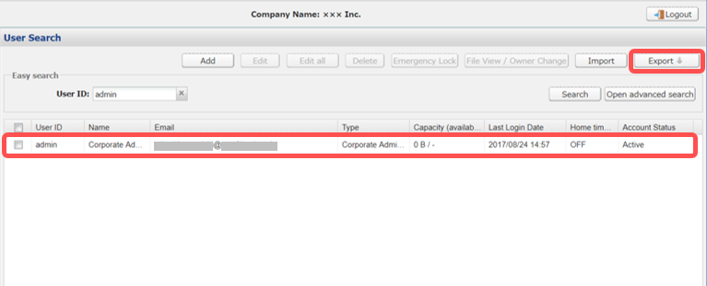

1. Select "Sharing settings (Per Sharing setting user)" and click "Download by search criteria" button.

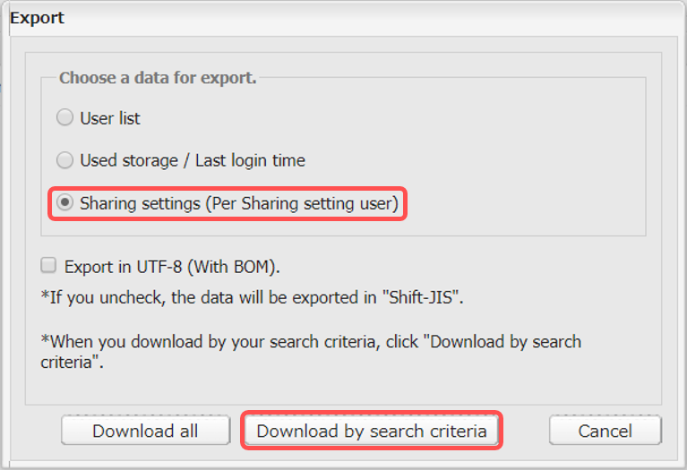

1. Edit the exported CSV file.

Enter "23 (Delete Share Member)" to the A column (Operation) of the sharers who are targeted to be deleted.

* A number of records can be operated at one time are up to 3,000.

If a number of records are more than 3,001, divide the records into smaller units and import multiple times.

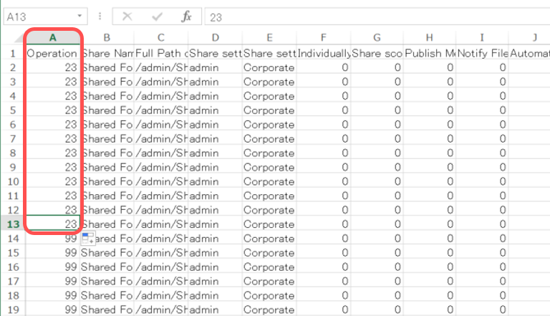

1. Click "Import" button on user search screen and select "Import Share Setting" tab.

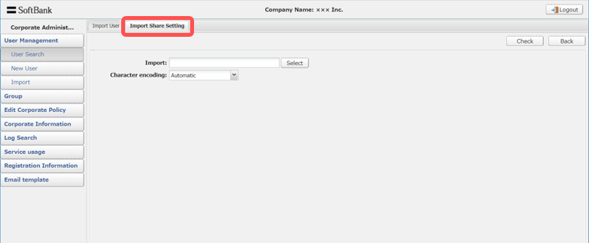

1. Select the edited CSV file and import it.

## Exporting User List, Current Data Usage / Most Recent Sign-in Date, Share Setting List

You can export the registered user list, current data usage/ Most Recent Sign-in date, share setting list to csv file.

* Default character encoding is Shift-JIS.
* If you want to export in UTF-8 (with BOM), please check “Export in UTF-8 (with BOM)”.

1. Select “User Search” from the left menu on the Main screen.
2. Click the "Export" button

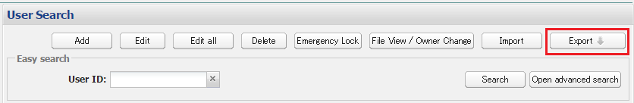

1. View the “Export” display.

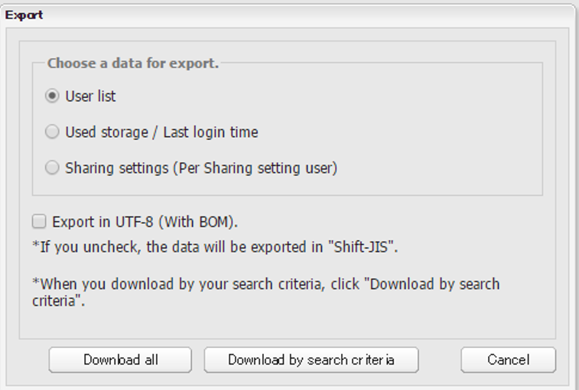

1. Select the information you want to output, and then click the download in all matter Download / search conditions.
   * + - 1. Search conditions Download

Before displaying the export screen, it should be specified search conditions.

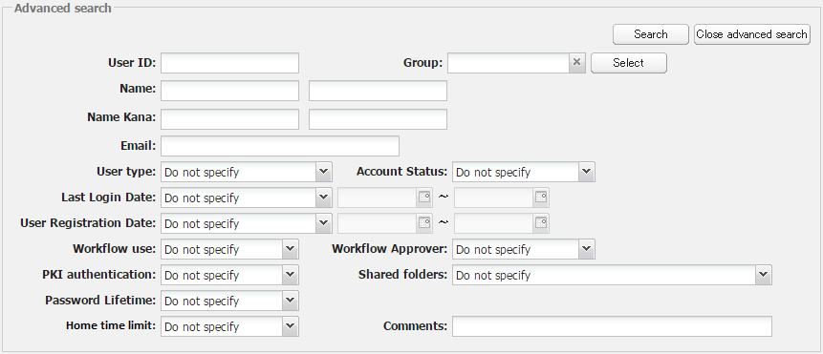

* Information for all users, excluding those that are under emergency lock, will be exported.
* The export operation is set as processing category 99.

(Format of user export)

User list will be exported to csv file. Character encoding is UTF-8(With BOM).

About exporting contents, please refer “Table3-6-1. Import User file (CSV) format”

＜Current Data Usage/ Most Recent Sign-in Date Export(CSV format)＞

Current Data Usage / Most Recent Sign-in Date will be exported to csv file.

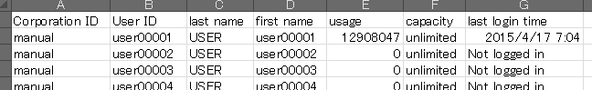

Account Using Capacity Export (CSV format)

|  |  |
| --- | --- |
| 項目名 | 説明 |
| Corporate ID | Run to Corporate ID |
| User ID | All Export: All User Export  Search conditions Export: Export user that matched |
| Last name | Last name |
| First name | First name |
| usage | View actual use capacity |
| capacity | View allocated capacity |
| last login time | last login time(UTC Format) |

＜Format of share setting＞

User share setting will be exported to CSV format. Character encoding is UTF-8(With BOM).

About exporting contents, please refer “Table3-7-1. Import share setting file (CSV) format”

## Locking User Accounts

1. Select “User Search” from the left menu on the Main screen and search for the target user.
2. Select the target user from the User Information screen and click the "Edit" button.
3. Set "Account status" to "Locked" and click the "Register" button.
4. Click "Confirm" on the next screen.
   * + - 1. Release account rock
5. Select “User Search” from the left menu on the Main screen and search for the target user.
6. Select the target user from the User Information screen and click the "Edit" button.
7. Set "Account status" to "Active" and click the "Register" button.
8. Click "Confirm" on the next screen.

## Emergency locking User Accounts

1. Select “User Search” from the left menu on the Main screen and search for the target user.
2. Select the target user from the User Information screen and click the "Emergency lock" button.

(Restrictions under emergency lock）

* Emergency locked users cannot login
* Send/Collect keys issued by the locked user become invalid.
* Other users can no longer access folders shared by locked users.
* The emergency lock cannot be applied to the corporate administrator.
* Send/Collect keys that have been invalidated by an emergency lock cannot be made valid again
* Folders shared by locked users will be come accessible again once the emergency lock has been released.
  + - * 1. Release the emergency lock

1. Select “User Search” from the left menu on the Main screen and search for the target user.
2. Select the target user from the User Information screen and click the "Edit" button.
3. Set "Account status" to "Active" and click the "Register" button.
4. Click "Confirm" on the next screen.

## File View / Owner Change

You can perform "View files/folders", "Change owner" and "Empty trash", of the target user.

### View files/folder

The following files/folders of the selected user can be viewed.

・ Files/folders in the home screen

・ Shared folders

・ Share Setting list

・ Files/folders in the Trash

1. Select “User Search” from the left menu on the Main screen and search for the target user.
2. Select the target user from the User Information screen and click the "File view" button.

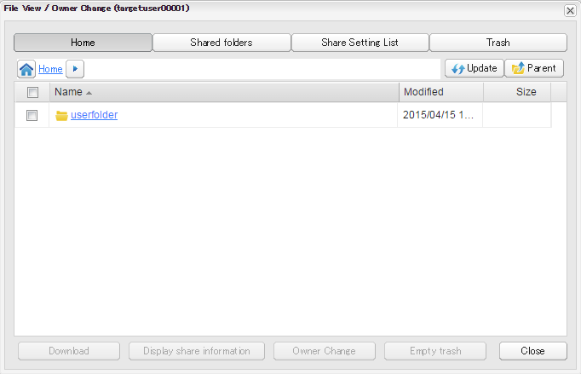

* The share settings for a shared folder can be viewed by pressing the “Display share information” button.

Please note this functionality is only available for folders where the user has the appropriate authority for viewing share settings.

### Owner Change

You can change the owner of the file to the other user, if the file has been no longer used due to personal changes or the like.

[Contents to be moved]

・ Shared folders and it’s under files/folders.

・ Share settings

・ Lock settings, Version settings (contain generations), Capacity settings, and File time limit settings.

・ Files/folders not shared

・ Private Groups (Only the group that has been added as a shared member)

[Contents NOT to be moved]

・ Share folder forums

・ Notice mails by sharing

・ Send/collect keys (The all keys become invalidate)

・ Files in the trash

・ Information registered in an address book

[Notice]

・ Maximum number of files/folders can be selected (checked) at one time is 1,000.

・ If you want to change the owner of more than 1,000 files, please performed several times.

・ If you Change owner of the folder include share setting, the setting "Individually set share (not inheriting)" on the share setting will be enabled.

・ Even if you change multiple files, the setting will be enabled across the board.

・ After the Owner Changed, you can NOT cancel the operation.

1. Select “User Search” from the left menu on the Main screen and search for the target user.
2. Select the target user from the User Information screen and click the "File View / Owner Change" button.

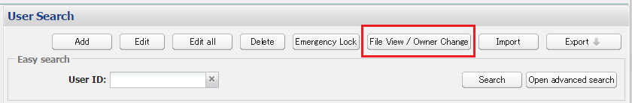

1. Select the files/folders then click the "Owner Change" button.

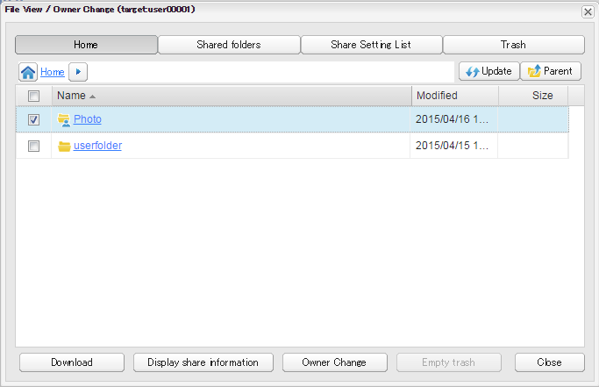

1. Click the "Select user" button and select the target user.

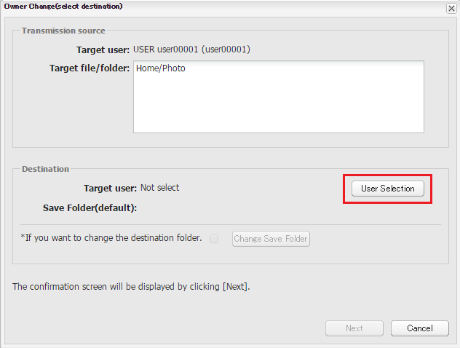

1. Select the target user, and the save folder will be displayed at "Save Folder (default)".
2. Confirm "Target user" and "Save Folder", then click the "Next" button.

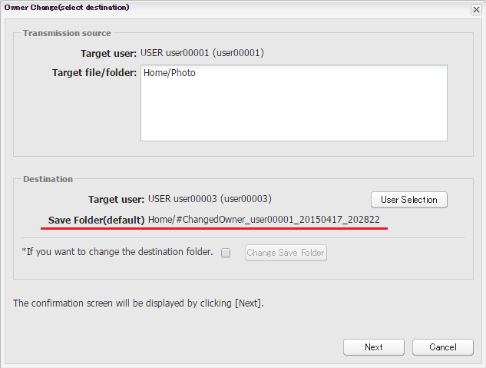

[Notice]

Save Folder (default) is created by PrimeDrive automatically.

If you want to change the save folder, please refer to [Change the save Folder of Owner Change]

1. Confirm contents and click the "Confirm" button on the confirm screen.

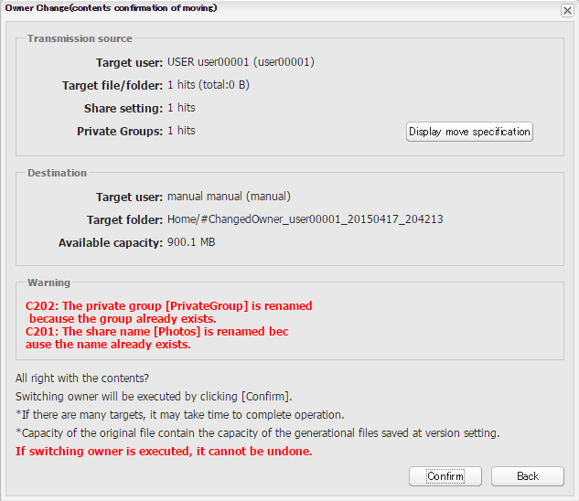

[Notice]

Click the "Confirm" button and the owner will be changed.

After the Owner Changed, you can NOT cancel the operation.

[Display the specification of move files/folders]

Click the "Display move specification" button and you can display move specifications of the files/folders, Share settings, and Private groups.

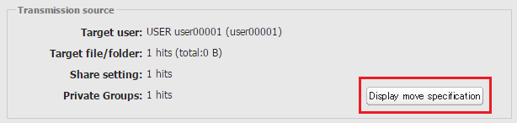

“Display move specification”

You can switch the list by pull down list.

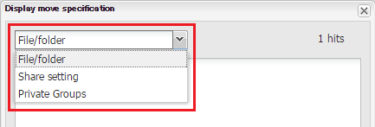

Folder/File List Share Setting (Share Name) List

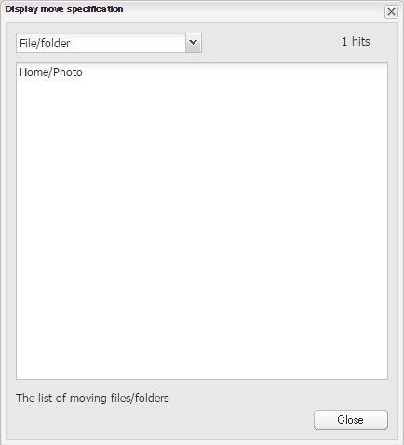 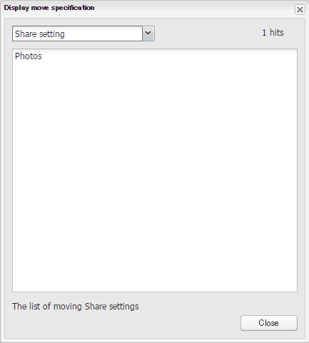

Private group List

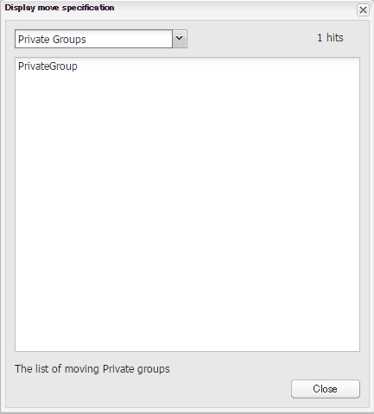

[Warning message]

If the destination uses Share name or Private group named same as the transmission source folder, Alert will be displayed.

For more details, please see [About warning message].

Example: Share name and Private group name duplication warning

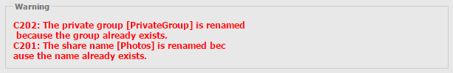

1. The message "Changed owner." is displayed and owner change will be completed.

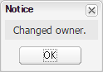

1. After owner changes completed, the moved content will be stored in the log.

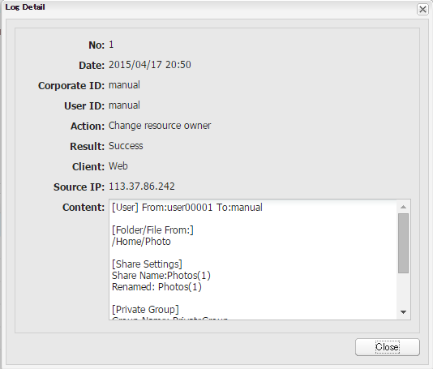

<Change the save Folder of Owner Change>

Owner change move the file to the folder PrimeDrive creates automatically, but you can specify any folder to save by "Change Save folder" button.

On this occasion, there is a risk that the file will be accessed by the other user.

Please execute after reading notes.

[CAUTION] Notice of Owner change

1. Move the shared folder to the other shared folder.

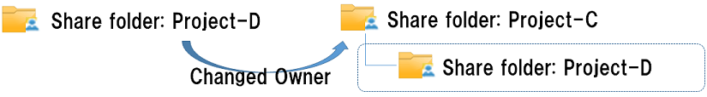

When you moved the share folder to the other share folder, the moved folder can be seen from parent folder.

1. Move the normal folder (not shared) to the share folder.

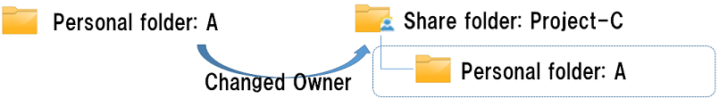

When you moved the normal folder(not shared) to the share folder, the moved folder can be seen from parent folder unintentionally.

1. Move the folder to the folder which Send key was issued.

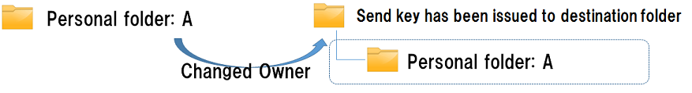

If the Send key has been issued to destination folder or its parent folder, the users who have the send key can access to the moved folder.

<Condition of issuing a send key that corresponds to the situation>

The case [Disable send key when updating the file] is unchecked.

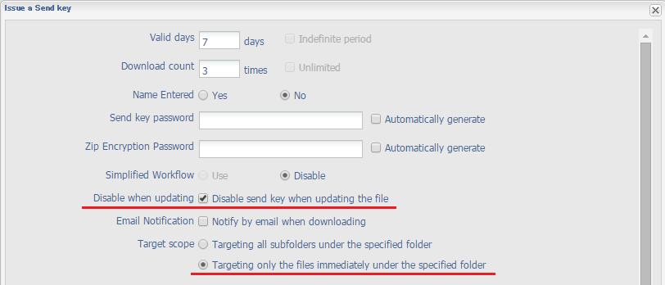

* **If you cannot judge your case will match the condition or not, you should click "Back", go to the default save file/folder, and move the file/folder while confirming apposite destination.**

1. Select “User Search” from the left menu on the Main screen and search for the target user.
2. Select the target user from the User Information screen and click the "File View / Owner Change " button.
3. Select the files/folders then click the "Owner Change" button.
4. Click the "Select user" button and select the target user.
5. Switch on the "If you want to change the Save folder name" checkbox on the Owner Change(select destination) screen.

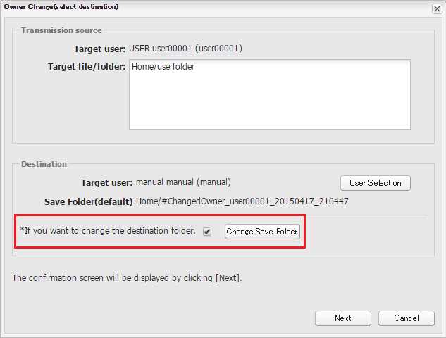

1. Click the "Change Save Folder", and the following message will be displayed.

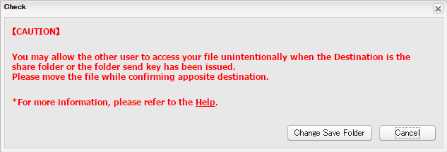

1. Click the "Change save Folder" and specify the save Folder.

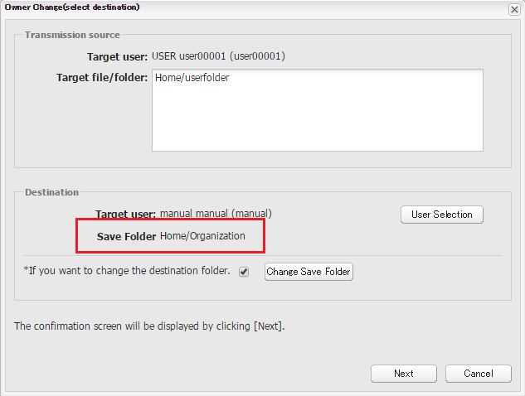

1. Confirm "Target user" and "Save Folder", then click the "Next" button.
2. Confirm contents and click the "Confirm" button on the confirm screen.
3. The message "Changed owner." is displayed and owner change will be completed.
4. After owner changes completed, the moved content will be stored in the log.

About warning message

|  |  |
| --- | --- |
| Warning 1 | C201 The share name [*xxxx*] is renamed because the name already exists. |
| Conditions | Warning message is displayed when Share name of Transmission source and Destination are duplicates. |
| Example | Share name of Transmission source: Photo  Share name of Destination: Photo  Share name after the owner changed: Photo(1) |

|  |  |
| --- | --- |
| Warning 2 | C202 The private group [*xxxx*] is renamed because the group already exists. |
| Conditions | Warning message is displayed when Private group of Transmission source and Destination are duplicates. |
| Example | Share name of Transmission source: Private Group  Share name of Destination: Private Group  Share name after the owner changed: Private Group(1) |

|  |  |
| --- | --- |
| Warning 3 | C203 The deadline of folder [*xxxx*] will be shorten to adjust the deadline of its superior directory. |
| Conditions | Warning message is displayed when the deadline of moved file is longer than that of parent folder. |
| Example | Deadline of Transmission source file: 30days  Deadline of Destination file: 7days  Deadline after the owner changed: 7days |

|  |  |
| --- | --- |
| Warning 4 | C204 The share list [*xxxx*] will be empty. |
| Conditions | Warning message is displayed when the Destination don't have share setting and the share setting of Transmission source has been canceled due to Emergency Lock. |
| Example | Share members of Transmission source:  user1(emergency lock), user2(emergency lock)  Share setting of Destination: none  Share setting after the owner changed: none |

|  |  |
| --- | --- |
| Warning 5 | C205 The capacitation setting of folder [*xxxx*] will be reset because the capacitation setting is larger than that of its superior directory. |
| Conditions | Warning message is displayed when the capacity of Transmission source is larger than that of Destination. |
| Example | Capacity of Transmission source: 50MB  Capacity of Destination: 25MB  Capacity after the owner changed: 25MB |

|  |  |
| --- | --- |
| Warning 6 | C206 The share name [*xxxx*] is renamed because the name already exists. |
| Conditions | Warning message is displayed when Share name of Transmission source and Destination are duplicates and when the file was exceeded the maximum number of characters by automatic renaming. |
| Example | Transmission source share name: ABCDEF...TUXYZ  * the maximum number of characters  Destination share name: ABCDEF...TUXYZ  * the maximum number of characters  Share name after the owner changed: ABCDEF...OMT(1)  *The letters [OMT] which means omitted the tail of the name, and consecutive numbers[n], will be added If the share name uses the maximum number of characters. |

|  |  |
| --- | --- |
| Warning 7 | C207 The private group [*xxxx*] is renamed because the group already exists. |
| Conditions | Warning message is displayed when Private group of Transmission source and Destination are duplicates and when the file was exceeded the maximum number of characters by automatic renaming. |
| Example | Transmission source share name: ABCDEF...TUXYZ  * the maximum number of characters  Destination share name: ABCDEF...TUXYZ  * the maximum number of characters  Share name after the owner changed: ABCDEF...OMT(1)  *The letters [OMT] which means omitted the tail of the name, and consecutive numbers[n], will be added If the share name uses the maximum number of characters. |

|  |  |
| --- | --- |
| Warning 8 | C208 The share folder [*xxxx*] contains the emergency locked user. The user will be excluded from the share member. |
| Conditions | Warning message is displayed when the share members of Transmission source are Emergency Locked. |
| Example | Share members of Transmission source:  user1, user2(emergency lock)  Share setting after the owner changed: user001 |

|  |  |
| --- | --- |
| Warning 9 | C209 All the members of share folder [*xxxx*] are emergency locked users. Their share setting at the destination will be canceled. |
| Conditions | Warning message is displayed when the all share members of Transmission source are Emergency Locked. |
| Example | Share members of Transmission source:  user1(emergency lock), user2(emergency lock)  Share setting after the owner changed: Release |

|  |  |
| --- | --- |
| Warning 10 | C210 There is the share setting [*xxxx*] at the destination folder or its parent folder. The file/folder will be in danger of accessing by superior share members. |
| Conditions | Warning message is displayed when not shared folder moved to shared folder. |
| Example | Folder of Transmission source: Normal folder  Folder of Destination: Share folder |

<About Log>

After owner changes completed, the moved content will be stored in the log.



<Information of Export log>

|  |  |  |
| --- | --- | --- |
| Item Name | Log Information | Item Description |
| [User] | From: *UserID* To: *UserID* | * User ID of both Transmission source and Destination are output. |
| [Folder/File From:] | /*Folder name*/*File name* | *File/Folder names of both Transmission source and Destination are output.  *File/folder names of all targets are output. |
| [Share Setting] | Share Name: *Share name* | *Share name is output. |
| Renamed: *Share name(n)* | *Output when the share names were renamed. |
| [Private Group] | Group Name: *Private Group name* | Private Group name |
| Renamed: *Private Group name(n)* | *Output when the private groups were renamed. |
| [Folder/File To:] | /Destination folder name | *File/Folder name of Destination is output. |

### Empty trash

You can empty trash of target user.

1. Select "User Search" from the left menu on the Main screen and search for the target user.
2. Select the target user on the user search screen, then click the "File View / Owner Change" button.

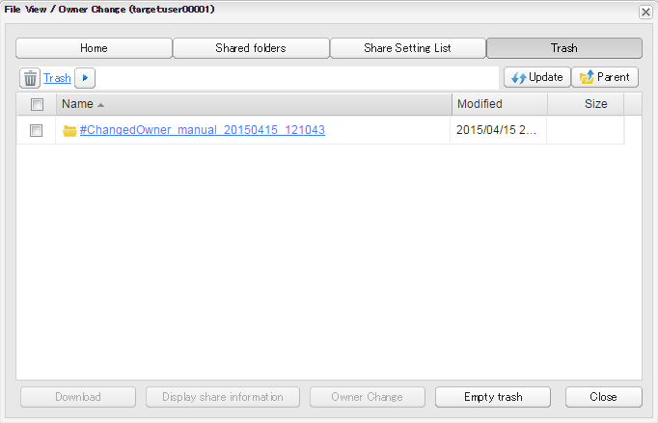

1. Click the "Trash" button, and then the Trash of target user will be displayed.
2. Click the "Empty trash" button.

# Corporate Administration

## Editing Corporate Policies

1. Select "Edit Corporate policy" from the left menu of the Main screen.
2. Edit Corporate Policy screen will appear.
3. Edit the registered information and click the "Register" button.

Certification：PrimeDrive edit screen

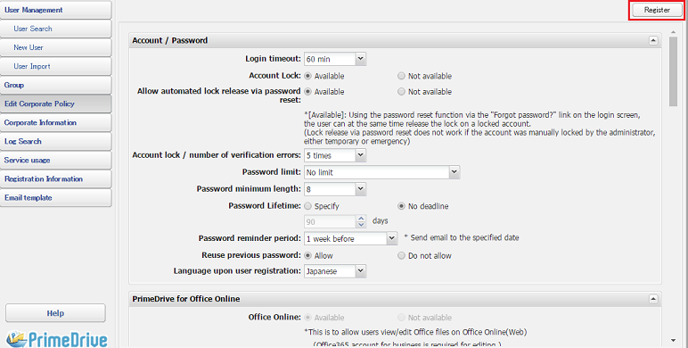

Certification：LDAP edit screen

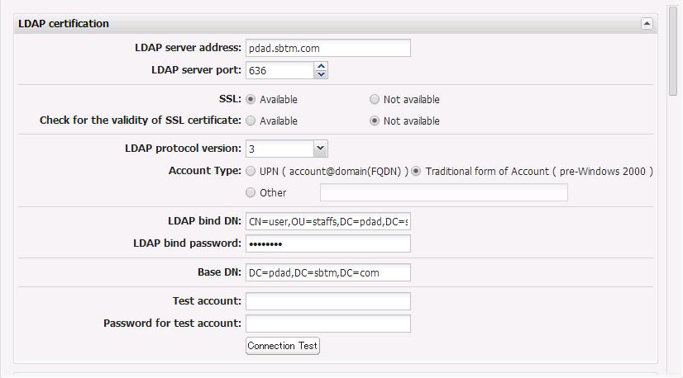

Certification：SAML edit screen

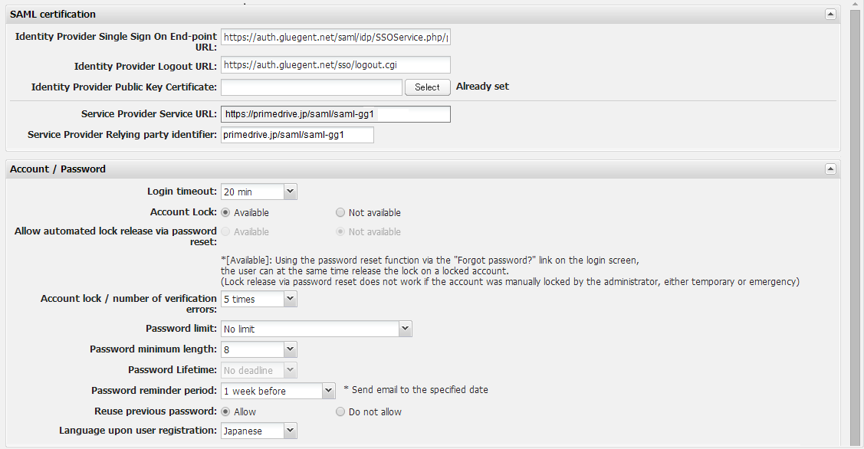

Corporate Policy Items

|  |  |  |  |
| --- | --- | --- | --- |
| Item Name | Item Description | | Input |
| Account/Password | | | |
| Login timeout | If inactivity continues for the specified period, the account will be logged out in 10/20/30/60 minutes/4 hours/12 hours. | | Required |
| Account lock | Enables the account lock functionality. When there are a number of failed attempts during login authentication a lock is manually possible through the administrator. | | Required |
| Allow automated lock release via password reset | By operating the password reset from the option "Forgot password?" in the login screen, you can set using your account automatically unlocked.  * If you set authentication method to LDAP or select "Disable" for SAML with PD authentication sharing option, "Disable" is automatically selected.  Available / Not available | | - |
| Account lock  /number of  verification errors | If authorization is failed the specified number of times, the account is locked.  3 failures / 5 failures / 7 failures | | Required |
| Password limit | Sets the characters that can be used in the password.  No limitation / Alphanumeric required / Mixed-case alphanumeric required / Ascii special characters required | | Required |
| Password minimum  length | Sets the minimum length for the password.  4/6/8 | | Required |
| Password expiration date | You can set the password expiration.  *If you set authentication method to LDAP or select "Disable" for SAML with PD authentication sharing option, "Disable" is automatically selected.  1 month / 3 months / 6 months / 1 year / No limit | | Required |
| Password reminder  period | Sends a notification email that before the password expiration date reminding the user of the expiration.  3 days before / 1 week before / 1month before | | Required |
| Reuse previous password | Set whether permit or not permit the password which was set at last time. | | - |
| Language | Selects the initial language when creating users. Notification emails will be sent in the specified language.  Japanese/English | | Required |
| PrimeDrive for Office Online | | | |
| Office Online | This is to allow users view / edit Office files on Office Online (Web).  *Only the Corporate Administrators can change this setting.  Please see 4-1-2.PrimeDrive for Office Online for more details. | | - |
| Available/Not avilable | Permission of viewing |
| Office apps(iOS) | This is to allow users opening Office files stored in PrimeDrive from Excel, Word or PowerPoint applications on iPad / iPhone. | | - |
| Available/Not available | |
| Send Key | | | |
| Upper limit days of send key expiration | Specify the upper limit days of send key expiration. (Default : 90 days） | | - |
| 1～90 | |
| Upper limit indefinite days of send key expiration | Set permission to use “send key valid days=indefinite” when you create a send key. (Default : not allow)  * If you set to "Allow", you can select "send key valid days=indefinite" when you create a send key.  “Allow” “Not allow” | | - |
| Unlimited Send  key downloads | Allows setting of unlimited downloads from a send key.  Allow / Do not allow | |  |
| Automatic deletion of a sending key expiration file | It is a use permission setup of an "automatic deletion of sending key expiration file" function at the time of sending key issue.(Default "disuse")  * When "use" is chosen, a user can choose more nearly arbitrarily than a sending key issue screen.  Moreover, when "compulsion" is chosen, "use" is compulsorily applied to all the users, and the user can’t release that.  (Use / disuse / compulsion) | | - |
| Minimum lengths of send key password | Set send key password in the range of minimum length. (Default “No limit”)  * Users, whose user policy “Send key password : not required” is set, are needed to enter password that include minimum length or more only when they set send key password.  * This setting is applied only when users enter a send key password manually. | |  |
| No limit / 4 figures / 6 figures / 8 figures | |
| Collect Key | | | |
| Upper limit days of collect key expiration | Specify the upper limit days of collect key expiration.  (Default : 90 days) | | - |
| 1 - 90 | |
| Upper limit indefinite days of collect key expiration | Set permission to use “collect key valid days=indefinite” when you create a collect key. (Default : not allow)  *If you set to "Allow", you can select " collect key valid days=indefinite" when you create a collect key.  “Allow” “Not allow” | |  |
| Select a Mailer | | | |
| Send a web-mail | Displays/Hides the "web-mail" button on the "Select a Mailer" screen.  Available/Not available | | - |
| Send a local mail | Displays/Hides the "local mail" button on the "Select a Mailer" screen.  Available/Not available | | - |
| Send by Gmail | Displays/Hides the "Send by Gmail" button on the "Select a Mailer" screen.  Available/Not available | | - |
| Mobile devices | | | |
| Cache time on  mobile devices | Sets the cache time in the mobile device.  When you set “0 day”, cannot use PrimeDrive for Office Online in iPad/iPhone. | | Required |
| Indefinite Period / 0 days / 1 day / 5 days / 10  days / 30 days / 90days | |
| Save password on  mobile devices | Allows saving passwords on mobile devices.  Allow password save / Do not allow password  Save | | - |
| Extending time-out of login from mobile devices (time) | Set extending time-out of login for mobile devices.  * Prior to setting “Login time-out”  ** This function will appear only if extending time-out of login is set as "Use". | |  |
| 1 - 12 | |
| Capacity warning | | | |
| capacity warning | The system automatically sends a warning email when the amount of free space has reached a certain threshold (%) with respect to the total amount of space allocated to user as per their contract. This warning email is sent to all users with administrator authority once a day.  Warn / Do not warn | | - |
| capacity warning /  remaining capacity | Specified notification to be sent through a capacity warning email, 1 to 99 | | - |
| IP address connection restriction | | | |
| IP address  connection  restriction | Restricts access to the global IP address environment.  Restrict / Do no restrict / Restrict connections  from the Internet | | - |
| List of connection  allowed IP  addresses | Specifies the permitted global IP addresses and/or range. | | - |
| PKI authentication | | | |
| PKI authentication | Performs login authentication through a PKI client certificate.  Available/Not available | | - |
| PKI  authentication/  Public OU | Registers the PKI OU number (Organization Unit Code)  Example: P4000000999 | | - |
| Home time limit setting | | | |
| Home time limit setting | It set the deadline set for each user ID. | |  |
| Available / Not available | |
| "Home time limit setting" of the user who owns the file | You can also set the deadline for the specified user ID who has already had their own data | |  |
| Allow / Do not allow | |
| Target of time limit setting | You set the item you want to apply the settings. | |  |
| Files / Folders and files | |
| 1 – 90 | |
| Report delete notice mails | When it gets closer to the deadline, notification email is sent to users automatically. | |  |
| Notice / Not Notified | |
| 1 day before, 3 days Before, 7 days before (initial value 3 days before) | |
| Certification：LDAP *1 | | | |
| LDAP server address | Set the address of LDAP server | | - |
| ex：10.10.10.1 or pdadldap.pdad.sbtm.com | |
| LDAP server port | Set the port of LDAP server port | | - |
| 389（LDAP）/636（LDAPS） | |
| SSL | Set the use of SSL | | - |
| Available（LDAPS）//Not available（LDAP） | |
| Check for the validity of SSL certificate | Set the use of Check for the validity of SSL certificate | | - |
| Available/Not available | |
| Check for the validity of SSL certificate | Set the validity of SSL certificate | | - |
| 2/3 | |
| Account Type | Set the Account Type | | - |
| UPN (account@domain(FQDN) / Traditional form of Account ( pre-Windows 2000 ) / Other form * Arbitrary attribute names are set up. | |
| LDAP bind DN | Set the LDAP bind DN | | - |
| ex：CN=user,OU=staffs,DC=pdad,DC=sbtm,DC=com | |
| LDAP bind password | Set theLDAP bind Password | | - |
| ex：sbtm@000 | |
| BASE DN | Set the BASE DN | | - |
| ex：DC=pdad,DC=sbtm,DC=com | |
| Test account | Set the Test account | | - |
| ex：pdadbind0 | |
| Password for test account | Set the Password for test account | | - |
| ex：sbtm@000 | |
| SAML authentication *2 | | | |
| Idp SSO endpoint address | Set SSO endpoint URL (HTTP-Redirect) of Identify Provider.  * Set SAML as an authentication method. | | - |
| Set destination for SAML authentication request. | |
| Idp log-out processing address | Set transition URL after log-out from PrimeDrive. | | - |
| Set Identify Provider URL displayed after log-out from PrimeDrive. | |

|  |  |  |  |
| --- | --- | --- | --- |
| Item Name | Item Description | | Input |
| Idp Public Key Certificate | | Set certificate of public key being used by Identify Provider to sign. | － |
| Attach certificate file of public key. |
| SP service URL | | Set redirect destination after SAML authentication. | － |
| Automatically set redirect destination URL from system. |
| Service Provider Relying party identifier | | Set SP identifier. | － |
| Automatically set SP identifier from system. |

*1 the input items are for LDAP authentication user. Please refer to the separate documentation for details.

*2 the input items are for SAML authentication user. Please refer to the separate documentation for details.

### Home time limit setting

Administrator can set up file time limit to user’s home by this function.

Folders or all of files below user’s home are target of file time limit by this function.

1. Setting up the time limit by “Editing Corporate Policies”.
2. Setting up the time limit each user ID by “User edit/all at once edit”.

<Editing Corporate Policies>

[Edit screen of Corporate Policies]

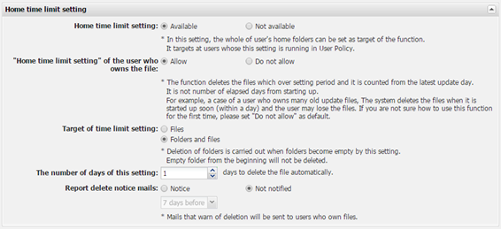

[Items to set up home time limit]

|  |  |
| --- | --- |
| Item Name | Item Description |
| Home time limit setting | Available  It is available to use it to user’s home. |
| Not Available  It is not available to use it to user’s home  In this case, It is set up by users as it used to. |
| “Home time limit setting” of the user who owns the file | Allow  This also can do it to users who already own data.  Please see <Instruction of using home time limit setting> for proper use. |
| Do not allow  This only can do it to users who don’t own data. |
| Target of time limit setting | Files  The function deletes only files when it overs the setting period. |
| Folders and files  This function deletes all of data include folders when it overs the setting period.  Please see <Instruction of using home time limit setting> for proper use. |
| The number of days this setting | 1-90 days (default: 30) |
| Report delete notice mails | Notice  It is available to set up to mail it when the time limit deletion is just around the corner. |
| Not notified  Not mailing to notice of deletion even though the time limit deletion is just around the corner. |
| 1 day,3 days,7 days in advance (default: 3 days) |

[User edit screen]

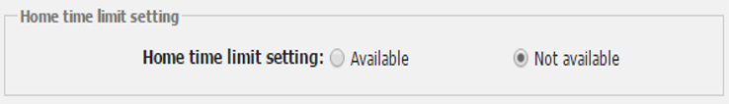

[Items of User edit screen]

|  |  |
| --- | --- |
| Item Name | Item Description |
| Home time limit setting | Available  It is available to set up it for each user ID.  Data below user’s home is the state which is setted up it as long as administrator unsets it. |
| Not available  Users set up it by themselves as it used to. |

It is available to confirm it in the User list.

[User List]

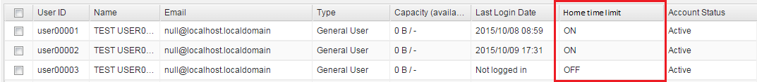

<Instruction of using home time limit setting>

・ The function applies the setting in the Corporate Policies to each user ID individually.

It doesn’t apply only to set up the Corporate Policies.

・ The system of automatic deletion of files deletes the files which over setting period and it are counted from the latest update day.

It is not number of elapsed days from starting up.

For example, a case of a user who owns many old update files, the system delete the files when it is started up soon (within a day) and the user may lose the files.

If you are not sure how to use this function for the first time, please set "Do not allow" as default.

### PrimeDrive for Office Online

<Editing Corporate Policies>

(PrimeDrive for Office Online)

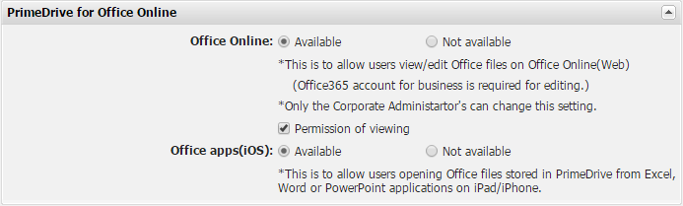

|  |  |
| --- | --- |
| Item Name | Item Description |
| Office Online  (Only corporate admin can set) | **Available**  ・Using Microsoft Office Online, you can edit files on the web browser.  ・On user screen of the web browser, “Edit in Office Online” will be available from pull down menu. *1  ・If you check “Permission of viewing”, “View in Office Online” will be also available from pull down menu.  **Not available(default)**  ・Not using Microsoft Office Online.  ・A user cannot use “Edit in Office Online” and “View in Office Online” from pull down menu on the web browser. |
| Permission of viewing (Only corporate admin can set) | **Checked**  ・Using Microsoft Office Online, you can view files on the web browser.  ・A user can use “View in Office Online” from pull down menu on the web browser.  **Unchecked (default)**  ・Viewing office files is not permitted in Microsoft Office Online.  ・A user cannot use “View in Office Online” from pull down menu on the web browser. |
| Office apps(iOS) (Sub-admin / corporate admin can set) | **Available**  ・You can edit/view Office files with Office apps in iOS devices. *1  **Not available(default)**  ・You cannot edit/view Office files with Office apps in iOS devices. |

*1 When you edit Office files, you need office 365 license for business.

|  |
| --- |
| **Office 365 licenses for both editing and viewing** |
| ・Office 365 Business  ・Office 365 Business Premium  ・Office 365 Business Essentials  ・Office 365 ProPlus  ・Office 365 Enterprise E1  ・Office 365 Enterprise E3  ・Office 365 Enterprise E5 |

**【Important】 About the files you open on Office Online**

**When you open the office file in Office Online, the file is temporarily cashed in the site for a period of term. (Microsoft specifications)**

**※Please make sure your company’s security policy before changing this setting.**

**※Only corporate administrator can change this function policy.**

## Viewing Subscription Information

If you select "Corporate Information" from the left menu of the Main screen, the Corporate Subscription Information Display screen will be displayed.

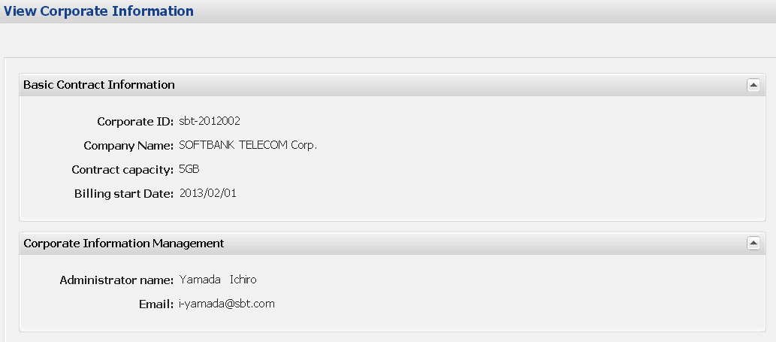

# Group Management

## Registering a New Group

Public groups are the only groups that can be managed on the corporate administrator screen.

1. Select "Group" from the left menu of the Main screen.
2. Click the "Add" button on the Group Information screen.

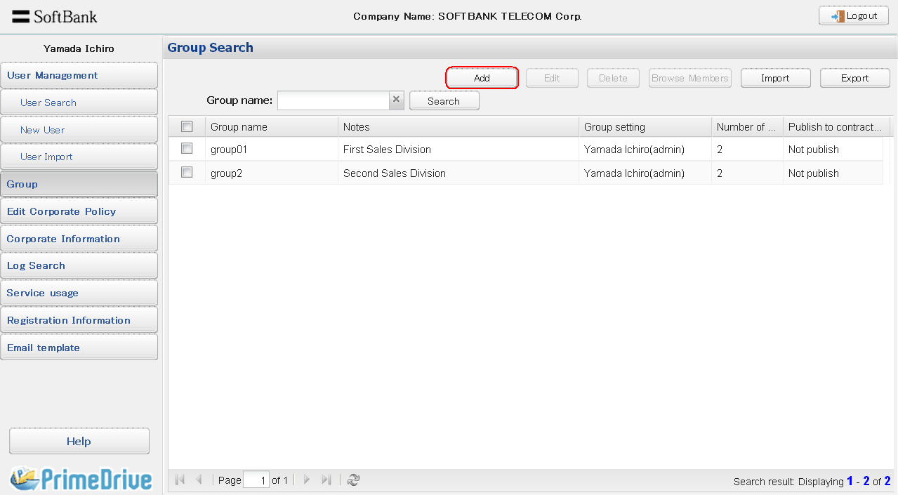

1. The "Group Editor: New” screen shows.

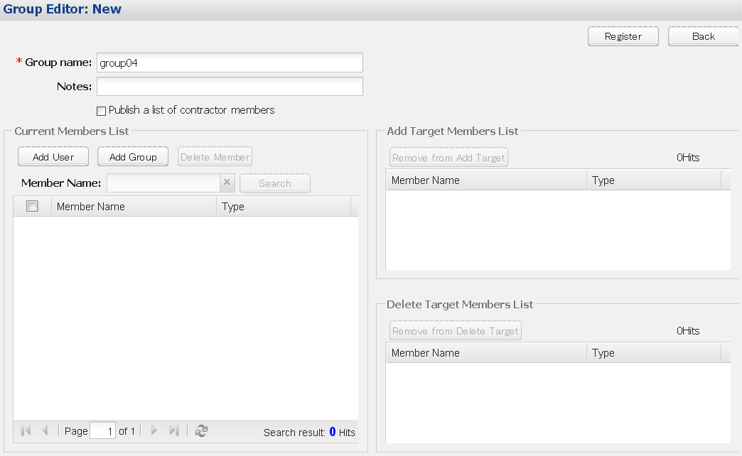

1. Enter a new group name.

(Add users)

Click on the "Add User" button to display the User Selection screen. Here, you can select a user to add to the group.

The selected user is listed in the “Add Target Members List” section on the right side of the screen.

If you wish to cancel the addition, select the user you wish remove and click the “Remove from Add Target” button.

* The maximum number of members that can be edited (add and delete) at once is 100.

For customers who register large numbers of users, please use the import function mentioned later.

* Search of when you want to add share members will be searched case-insensitive.

(Add group)

Click on the "Add Group" button to display the Group Selection screen. Here, you can select another group to add to this group.

The selected group is listed in “Add Target Members List” section on the right side of the screen.

If you wish to cancel the addition, select the group you with to remove and click the “Remove from Add Target” button.

* If "Publish members list to contractors" is checked, contractors will be able to view group members.
* Search of when you want to add share members will be searched case-insensitive.

1. Click on "Register" button

[Note]

The setter of a public group will always be the "corporate admin".  Even when sub-admins register a new group, the group setter will not be the sub-admin, but the "corporate admin".

## Editing a Group

1. Select "Group" from the left menu of the Main screen.
2. Enter the group name to be edited and click the "Search" button.

* Click the X icon beside the “Group Name” box clears group name input, causing information for all groups to be displayed.

1. Select (check) the target group from the group list and click the "Edit" button.

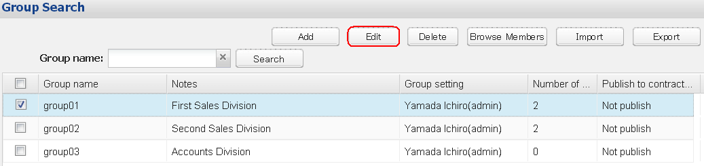

1. Display the Group Editor screen.

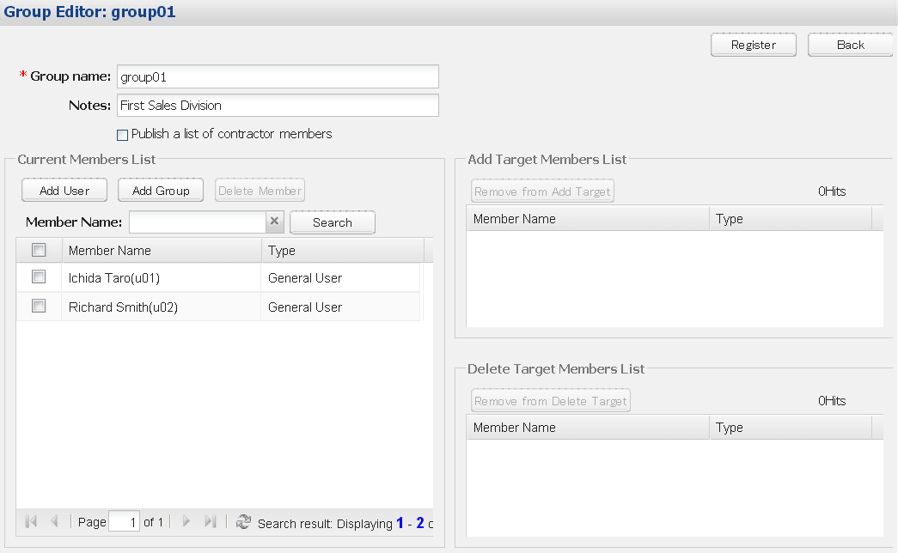

1. To add a user, click on "Add User" button to display the User Selection screen. Then, select the user to add to the group.

To add a group, click on "Add Group" button to display the Group Selection screen. Then, select the group to add to the group.

1. If you want to delete members from the group, select the member who you want to delete from the “Current Members List” and click the “Delete Member” button.
2. The selected members are displayed in the “Deleted Target Members List” section.

* If you wish to cancel a member deletion, select the members whose deletion you wish to cancel and click the “Remove from Delete Target” button.

1. Click the “Register” button.

## Deleting Groups

1. Select "Group" from the left menu of the Main screen.
2. Enter the group name to be edited and click the "Search" button.
3. Select (check) the target group from the group list and click the "Delete" button.

## Browse the group members.

1. Select "Group" from the left menu of the Main screen.
2. Enter the group name to be edited and click the "Search" button.
3. Select (check) the target group from the group list and click the "Browse Members" button.

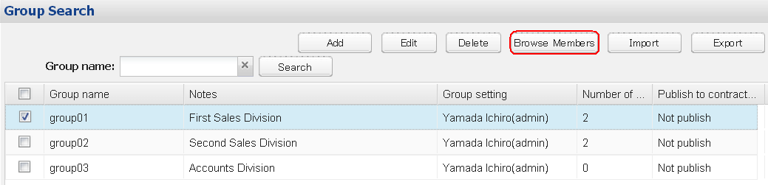

## Group Import

1. Select "Group" from the left menu of the Main screen.
2. Click the "Import" button.

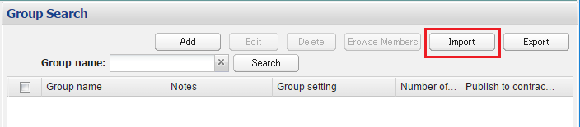

1. Display the Group Import screen.

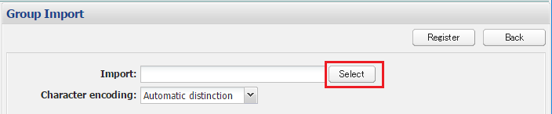

1. Click the “Select” button and select the CSV file for importing.

* The CSV file generated by the group export functionality can be used as a skeleton for the import file (CSV).

1. Click the "Register" button

Group Import file (CSV) format

|  |  |  |  |  |
| --- | --- | --- | --- | --- |
| Item Name | Required | Initial Value | Input Value | Description |
| Operation | ○ | - | 11 | Add groups |
| 12 | Edit groups |
| 13 | Delete groups |
| 21 | Add members |
| 23 | Delete members |
| 99 | None |
| Group Name | ○ | - | - | Within 255 characters  Special characters recommended to restrict “-“ hyphen, “_” underscore, “.”  period, “@” at sign (＊1) |
| memo | - | - | - | Within 140 characters  If using a “,” comma, surround the whole text  within “” double-quotations (Note 2) |
| Publish members  to Contract | - | 0 | 0 | Not publish |
| 1 | Publish |
| Type of member | - | - | 3 | User |
| 10 | Public group |
| Member ID | - | - | - | User ID / Group Name |

Special characters that are disallowed in the group name.

・ Disallowed character: “<” less-than

・　Characters that should be avoided: “\” yen mark, “”” double-quotation, “,” comma, “╲” backslash (half-width).

* If these special characters are used, the import functionality may not function properly.

Even if the import completes, the data may not be processed correctly when displayed on screen or upon the next export.

* Special characters in the memo

Characters that should be avoided: the same as Note 1.

・　If using a “,” comma, surround the whole text within “ ” ” double-quotations. (In this case, do not use more than 3 double-quotation marks)

* Maximum import number

・　The max number of importable items is 3000 for one operation.

・　The first row of the import file is processed as a column names.

## Group Export

Export the information about the registered public group to csv file. Character encoding is UTF-8(With BOM).

* Default character encoding is Shift-JIS.
* If you want to export in UTF-8(with BOM), please check “Export in UTF-8(with BOM)”.

1. Select "Group" from the left menu of the Main screen.
2. Click the "Export" button.

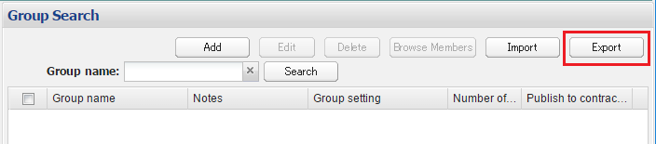

* Exporting by individual groups is not possible.

1. Click “Download all” / “Download by search criteria” button.

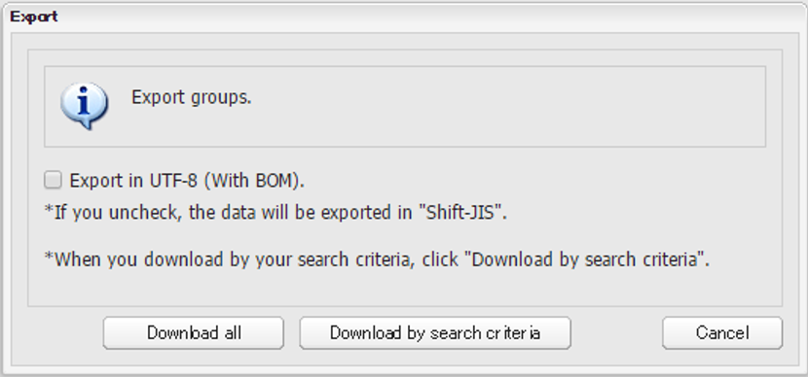

<The example of an export CSV file>

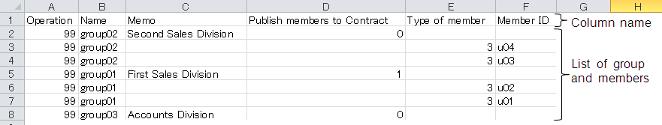

* By the export, 99 is set in the Operation section.

# IP Address Connection Limit

## How to Register IP Addresses

You can apply IP address connection limits per corporate or user account.

Corporate settings target all users belonging to a corporate account.

However, when a limit is established for individual user accounts, individual settings are given priority.

After completing the settings, you can only use services from registered IP address environments.

(How to register a global IP address)

Example: 192.168.1.1

Example: 192.168.1.1-20

## Applying or Releasing IP Address Connection Limits for the Whole Corporate Account

1. Select "Edit Corporate Policy" from the left menu of the Main screen.
2. The Edit Corporate Policy screen is displayed.
3. Select "Limit" on the IP address connection limit items.(When releasing the setting, select "No restriction".)
4. Enter the IP address to be registered in the Access permission range and click the "Add" button next to the item.
5. Check the information registered in the IP address list and click the "Register" button on the top right of the screen.

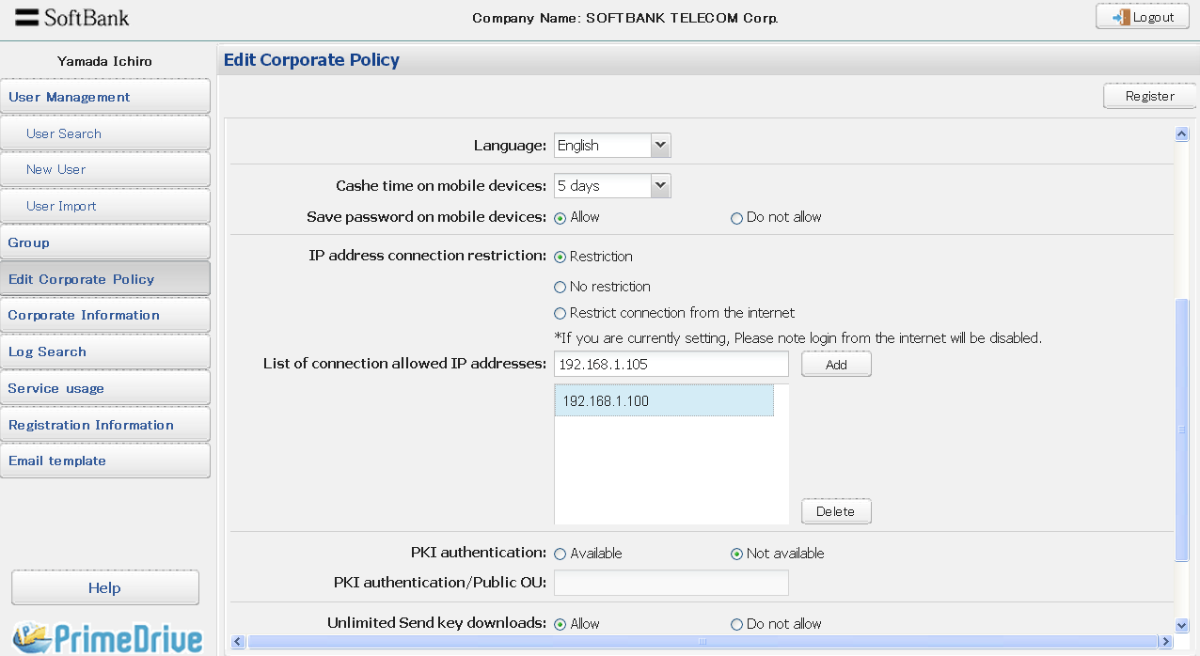

* The “Restrict connection from the Internet” setting is for restricting access to just closed-connection services that connect only from a closed network (Smart VPN/Internet VPN).

Enabling this setting will cause logins from the Internet to be rejected, so please be careful not to set it by accident.

## Applying or Releasing IP Address Connection Limits for Individual Users

1. Select “User Search” from the left menu on the Main screen and search for the target user.
2. Select the target user from the User Information screen and click the "Edit" button.
3. The Edit User Information screen is displayed.
4. Select "Apply a user policy" on the IP address connection limit items.(When releasing the setting, select "No restriction".)
5. Enter the IP address to be registered in the Access permission range and click the "Add" button next to the item.
6. Check the information registered in the IP address list and click the "Register" button on the top right of the screen.
7. Click "Confirm" on the next screen.

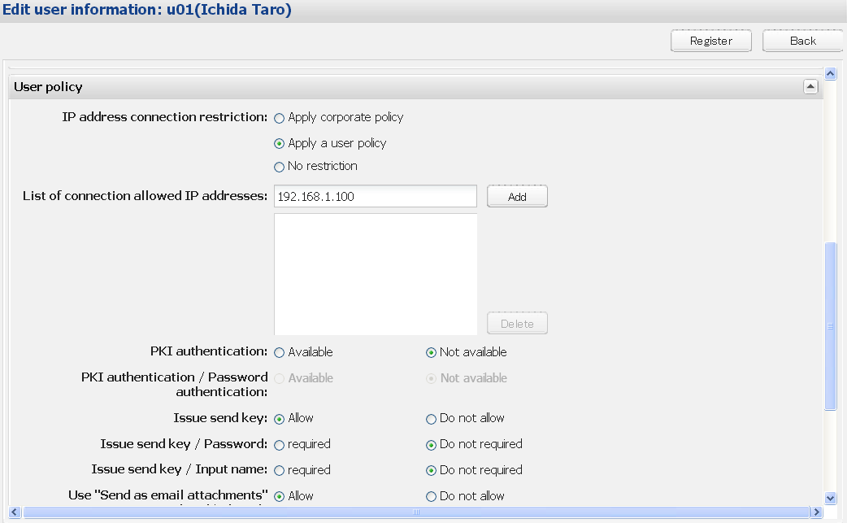

# PKI Client Authentication Function

## Setting Preparation In Advance

When using the PKI client authentication, you must set the corporate and user policies first.

* + - * 1. Registering a PKI service code in a corporate policy

1. Select "Edit Corporate policy" from the left menu of the Main screen.
2. The Edit Corporate Policy screen is displayed.
3. Set the PKI authentication item to "Available".
4. Enter the OU number (Organization Unit Code) in the PKI authentication/Public OU input field.
5. Click the "Register" button.

* For the OU number, see the activation notice you received when you applied for the PKI service.
* After completing user registration, use the login URL used exclusively for PKI client authentication.
* See Chapter 2 "Login" in the "User Manual" on how to login.
  + - * 1. Making PKI authentication available through the user policy of the target user

1. Select “User Search” from the left menu on the Main screen and search for the target user.
2. Select the target user from the User Information screen and click the "Edit" button.
3. The Edit User Information screen for the selected user is displayed.
4. Select "Available" on the PKI authentication items.
5. When enabling password authentication, select "Available" from the Password authentication items during PKI authentication and click the "Register" button.

* If you select "Not available", the Main screen right after login will be displayed after specifying the login URL without the login screen being displayed.）

1. Click "Confirm" on the next screen.

## Restrictions

If you want to use the PKI platform service, you must register CN information in the same information that is registered in the user ID and PKI client certificate used in PrimeDrive.

Please note that if it is not registered with the same information, you will not be able to use the service.

# Log Management

## Searching Logs

1. Select “Log Search” from the left menu of the Main screen.
2. Enter the search conditions in the Log Information screen and click the "Search" button.
3. The list of log information is displayed by the lower part of the screen.

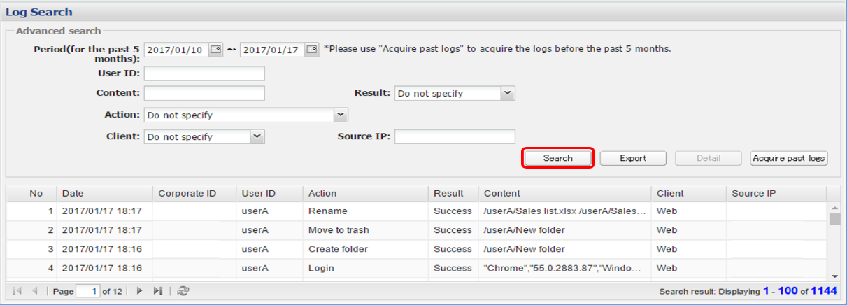

* The log search for this month and the past four months is possible. If you want to confirm the logs more than five months ago, please use "Acquire past logs".

## Detail Logs

1. Select a log item from the log information list and click the "Detail" button.
2. The Log Detail screen is displayed.

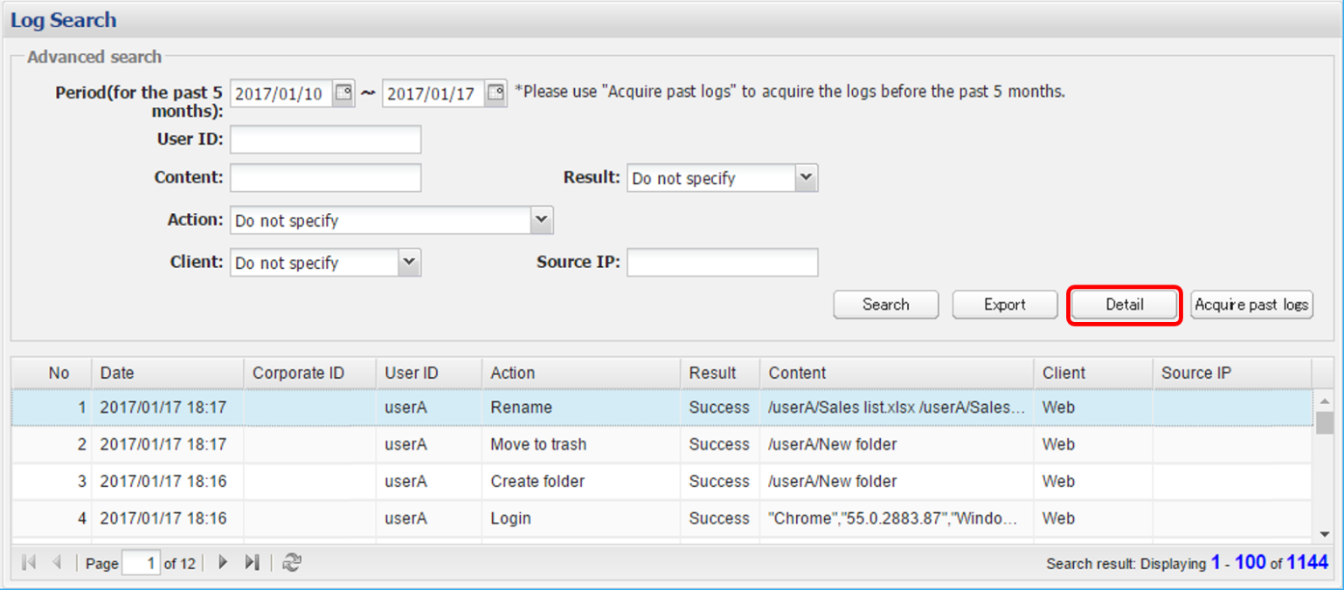

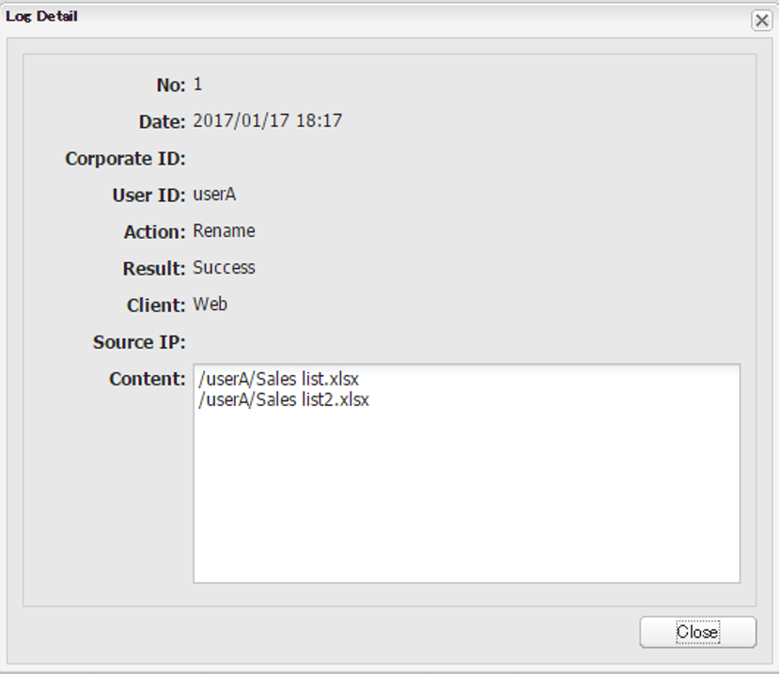

## Exporting Logs

Logs for the past four months up to the current month can be filtered via search, then exported.

1. Select "Log Search" from the left menu of the Main screen.
2. Input the search condition and click the "Export" button.
3. The log (CSV file) is downloaded in the appointed search condition.

* Logs are ordered by “Date”, starting with the newest date.
* Default character encoding is Shift-JIS.
* If you want to export in UTF-8 (with BOM), please check “Export in UTF-8 (with BOM)”.

## Acquiring past logs

Logs from more than 5 months prior are archived, so can only be downloaded in monthly units.

(The archive process runs at 00:00 on the 1st of every month)

1. Select "Log Search" from the left menu of the Main screen.
2. Click the "Acquire past logs" button on the Log Information screen.
3. Select the Date of log acquisition and click the “OK” button.

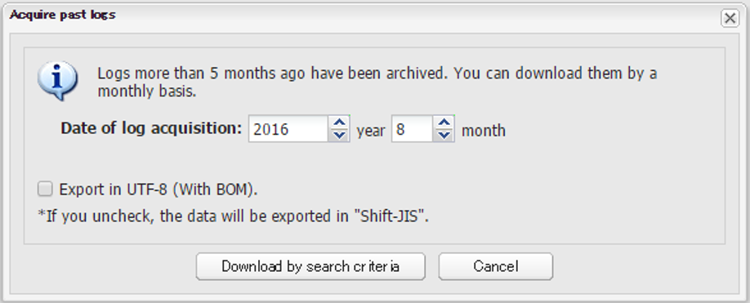

About retention period of logs

・ Retention period of logs is 5 years

# Service usage

## Checking Service usage

You can check service usage.

1. Select "Service usage" from the left menu of the Main screen.

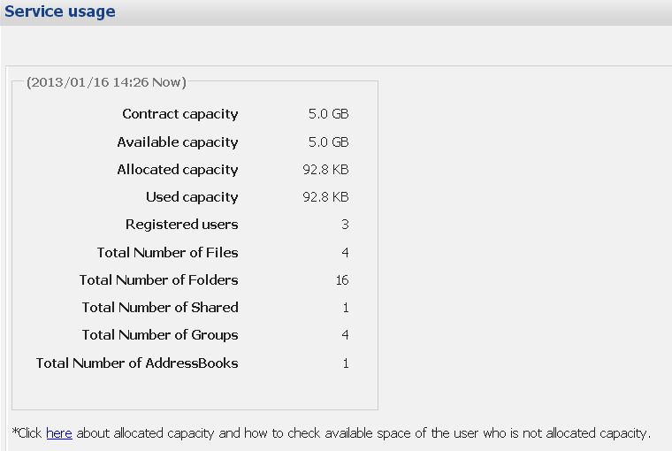

* Click the link at the bottom of screen for more information concerning allocated capacity policy and procedures for checking available capacity.

# Registration Information

## Registering Notice Information

Notice information will be open to all users belonging to the corporate account.

The Notice Information screen will be displayed right after logging in to the account.

1. Select Registration Information from the left menu of the Main screen.
2. Register notice details and click the "Register" button.

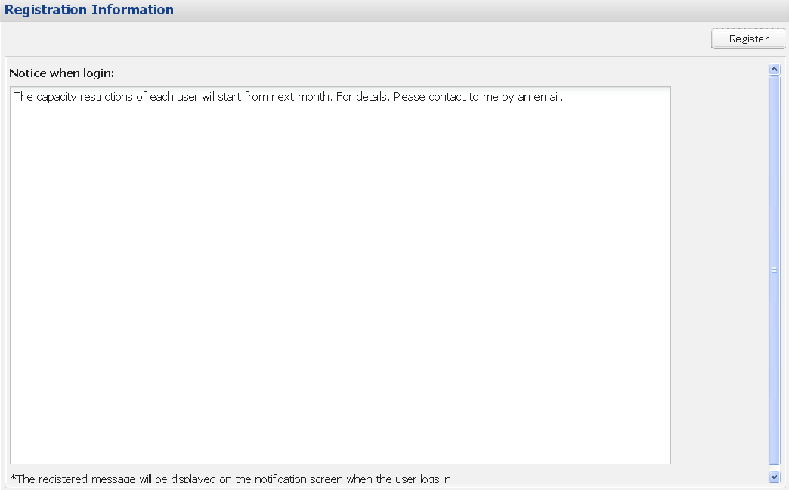

## Changing or Deleting Notice Information

1. Select "Registration Information" from the left menu of the Main screen.
2. Change or delete registered notice details and click the "Register" button.

# Notification Email Template Registration

## Notification Email Template Registration

You can change the header and footer of the following email. Enter text in Japanese or English when necessary.

* A default template is already registered so just change its contents and use it.

・ User entry completion

・ User entry completion (import)

・ Folder Sharing setting completion

・ Folder Sharing update completion

・ Send key issue

・ Approval request workflow

・ Recovery key issue

1. Select “Email Template” from the left menu of the Main screen.
2. Select the template you want to change from the pull-down list box.
3. Edit the registered sentences and press the "Register" button. * You can edit in Japanese or English.
4. Click the "Confirm" button on the next screen.

